CONSTRAINTS and ALTER TABLE

- Unique Constraint
Means can’t store duplicated values.

Code:

- CREATE TABLE contacts (
- name VARCHAR(100) NOT NULL,
- phone VARCHAR(15) NOT NULL UNIQUE
- );

- INSERT INTO contacts (name, phone)
- VALUES ('billybob', '8781213455');

- -- This insert would result in an error:
- INSERT INTO contacts (name, phone)
- VALUES ('billybob', '8781213455');

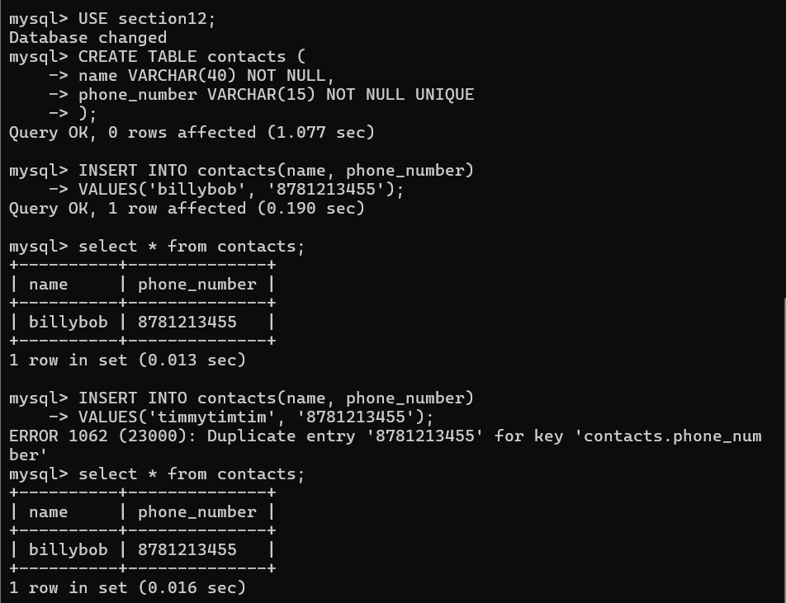

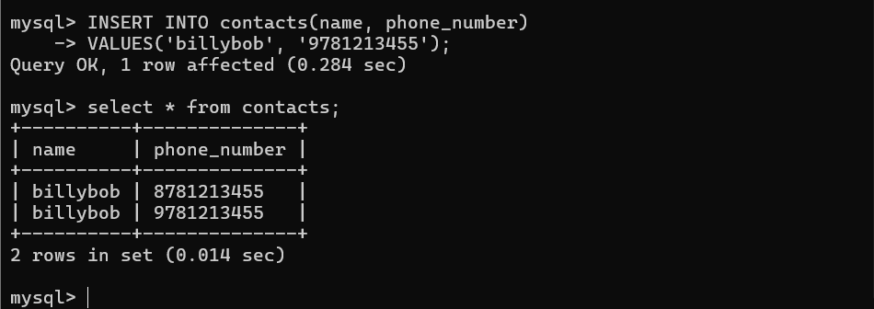

- CHECK Constraint

Expression that is going to be some sort of boolean true or false.

- CREATE TABLE users (
- username VARCHAR(20) NOT NULL,
- age INT CHECK (age > 0)
- );

—- age must be greater than 0

- CREATE TABLE palindromes (
- word VARCHAR(100) CHECK(REVERSE(word) = word)
- );

—- check if the word is palindrome or not either if the palindrome does not show the error or if it is not palindrome it shows an error message.

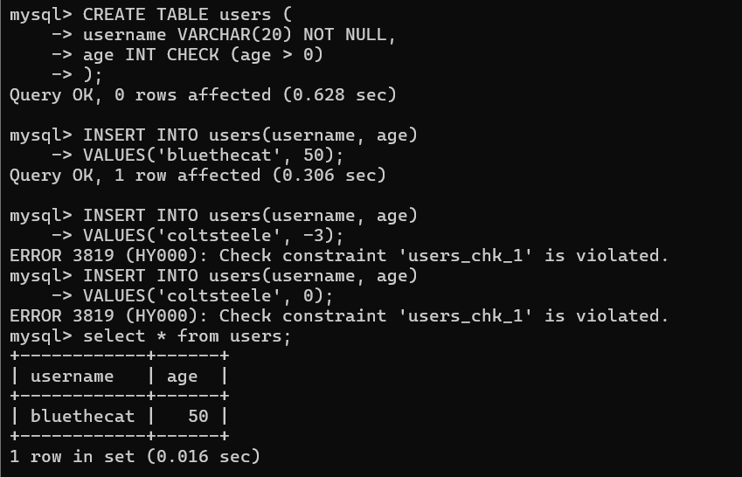

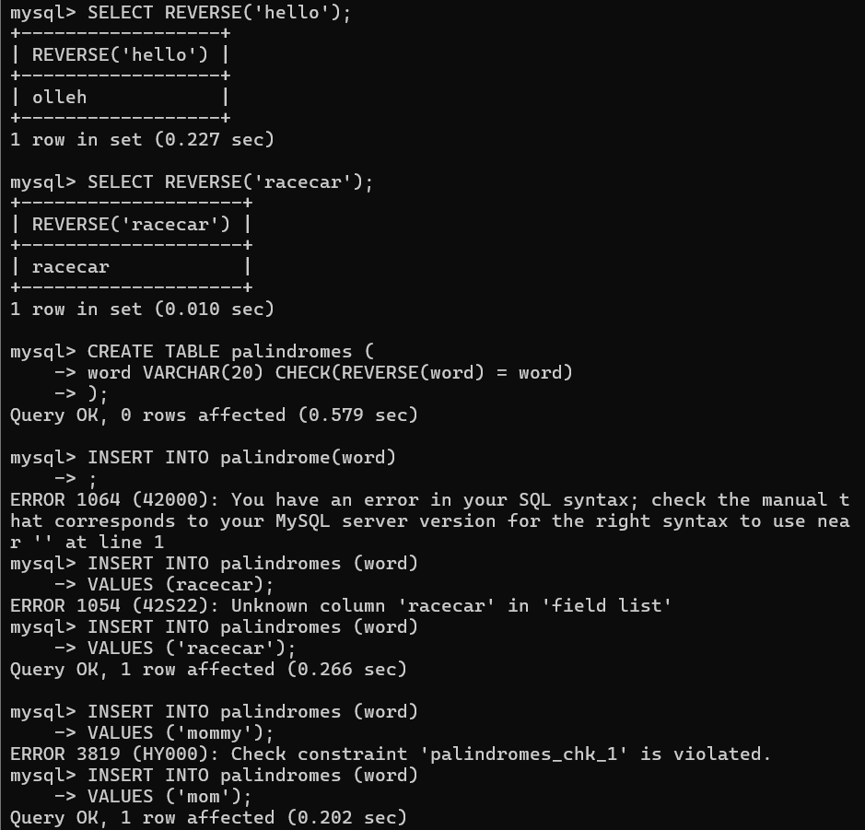

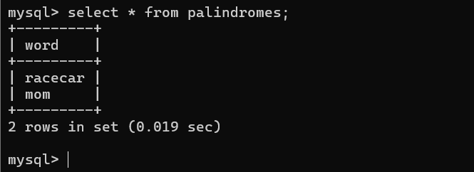

- Named Constraints
“The error message that appears when a constraint is violated is defined in the SQL code.”

- CREATE TABLE users2 (
- username VARCHAR(20) NOT NULL,
- age INT,
- CONSTRAINT age_not_negative CHECK (age >= 0)
- );

- CREATE TABLE palindromes2 (
- word VARCHAR(100),
- CONSTRAINT word_is_palindrome CHECK(REVERSE(word) = word)
- );

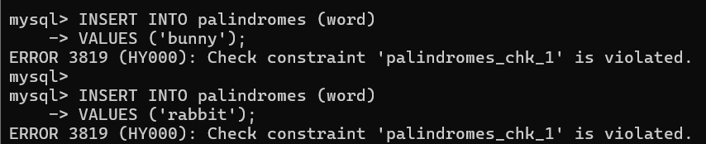
Palindromes_chk_1 violated shows the error message comes from the query not name constraint.

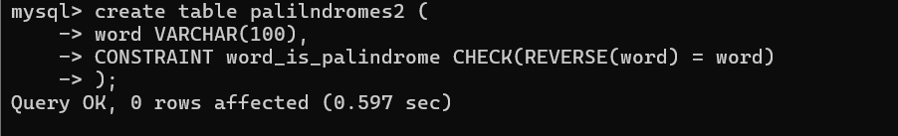

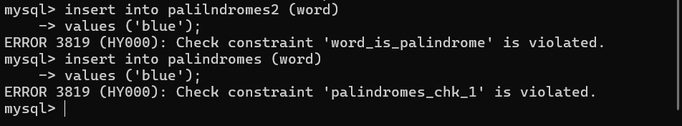

Word_is_plaindrome that error message comes from using name constraints.

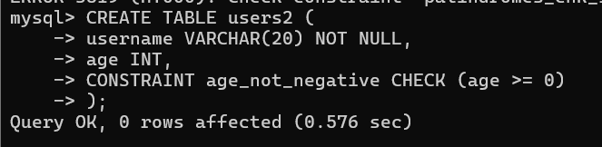

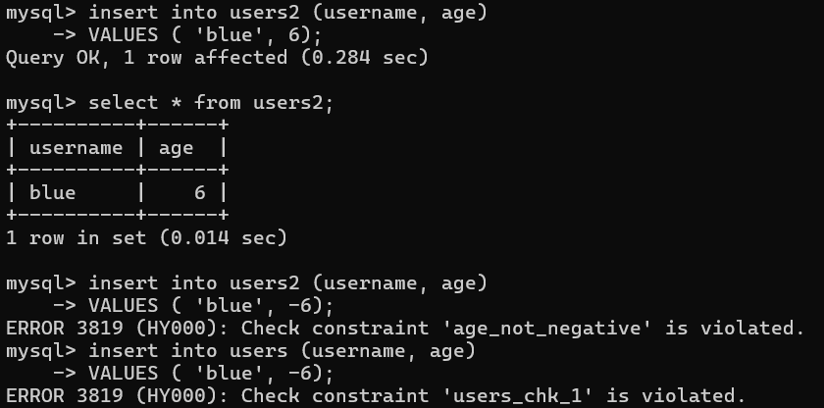

- Multiple column Checks

- CREATE TABLE companies (
- name VARCHAR(255) NOT NULL,
- address VARCHAR(255) NOT NULL,
- CONSTRAINT name_address UNIQUE (name , address)
- );

- CREATE TABLE houses (
- purchase_price INT NOT NULL,
- sale_price INT NOT NULL,
- CONSTRAINT sprice_gt_pprice CHECK(sale_price >= purchase_price)
- );

UNIQUE (name, address)
➜ The combination of name + address cannot repeat

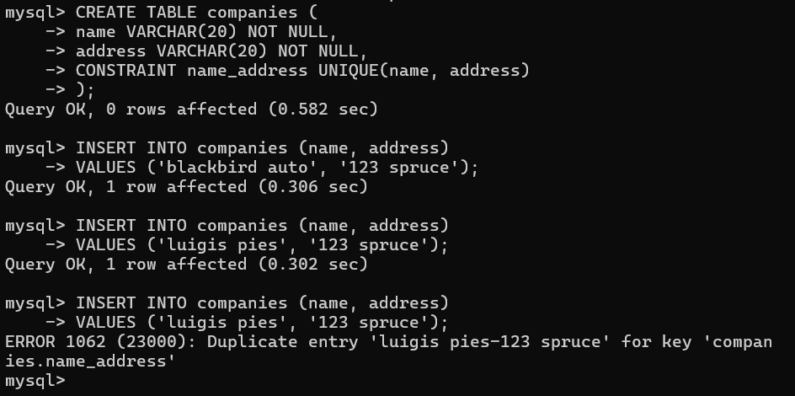

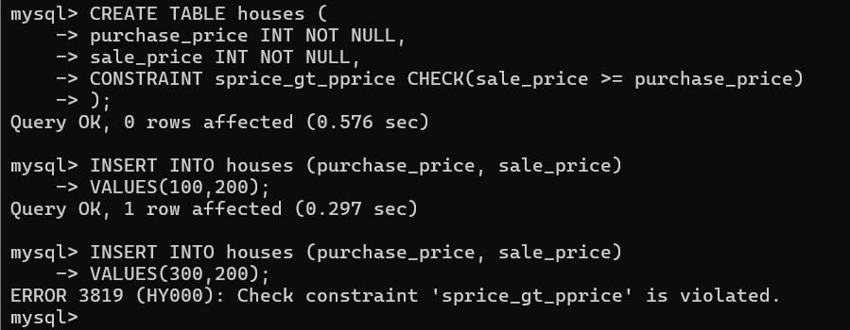

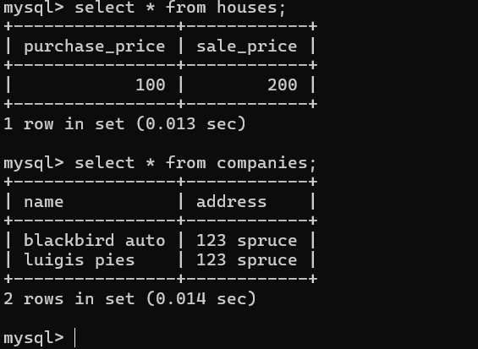

- ALTER TABLES -> Adding Columns

Add columns using alter.

CODE:

- ALTER TABLE companies
- ADD COLUMN phone VARCHAR(15);

- ALTER TABLE companies
- ADD COLUMN employee_count INT NOT NULL DEFAULT 1;

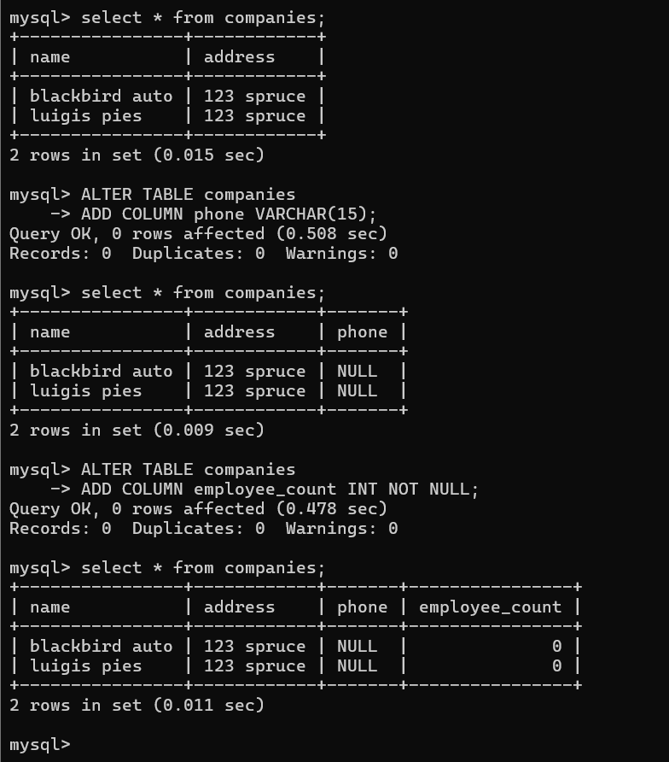

- Drop Column
Drop Column using ALTER.

- ALTER TABLE companies DROP COLUMN phone;

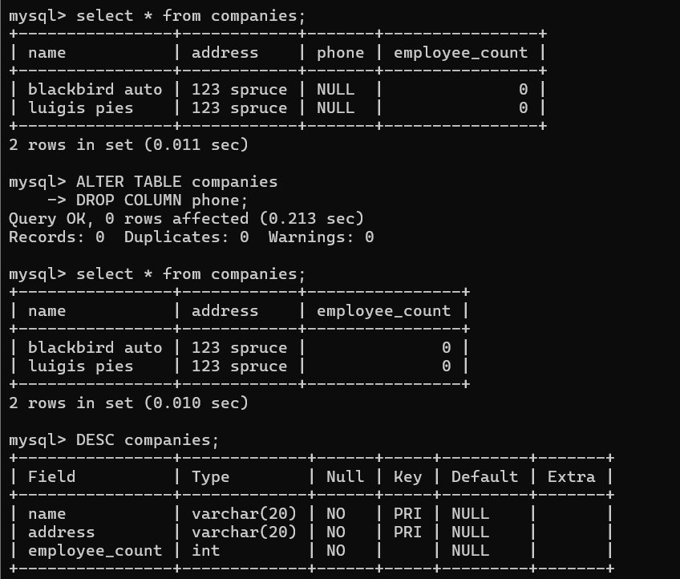

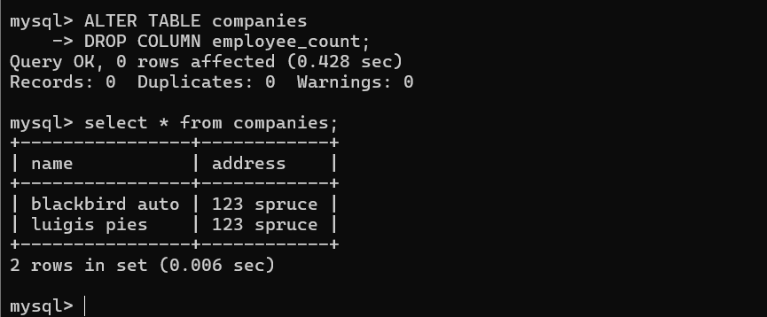

- ALTER TABLE -> Renaming

CODE:

- RENAME TABLE companies to suppliers;

- ALTER TABLE suppliers RENAME TO companies;

- ALTER TABLE companies
- RENAME COLUMN name TO company_name;

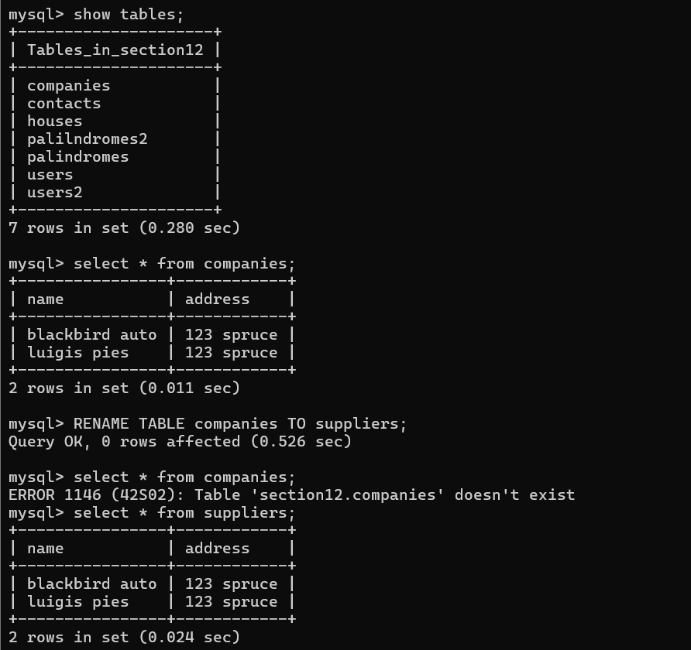

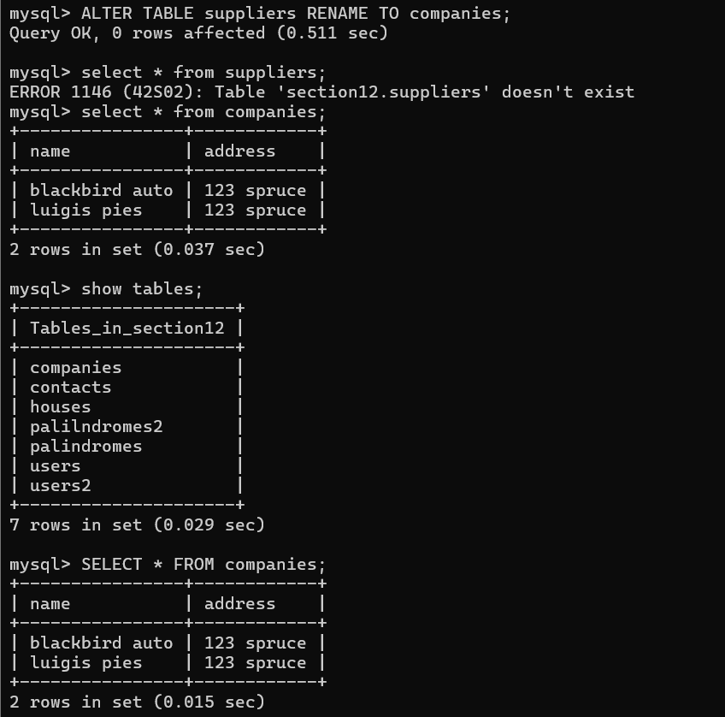

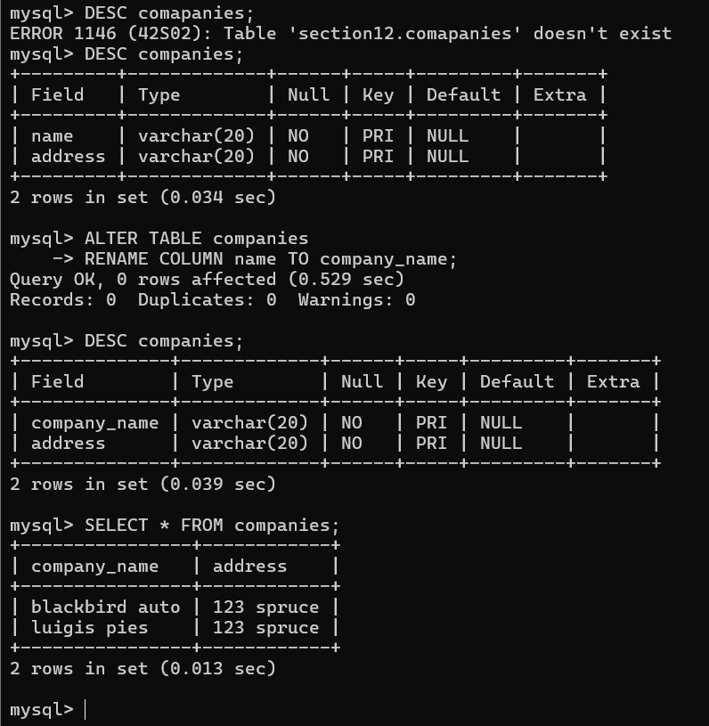

- MODIFY

Modify the column name or column data type and their values.
Varchar (200) change to varchar (100)

- ALTER TABLE companies
- MODIFY company_name VARCHAR(100) DEFAULT 'unknown';
- ALTER TABLE suppliers
- CHANGE business biz_name VARCHAR(50);

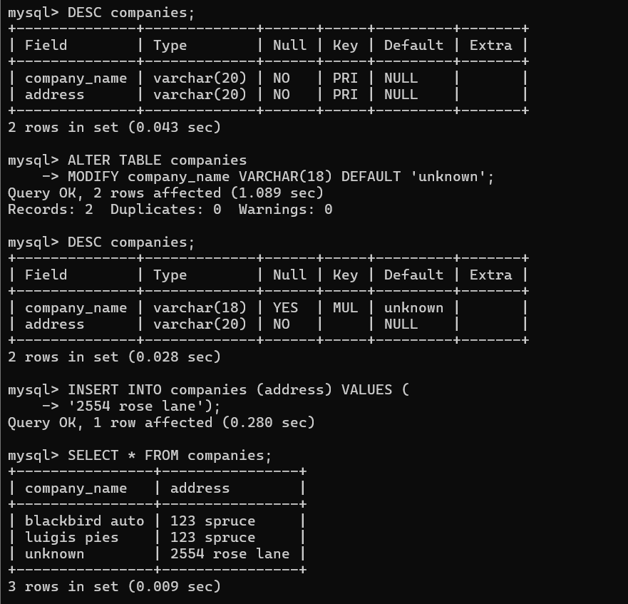

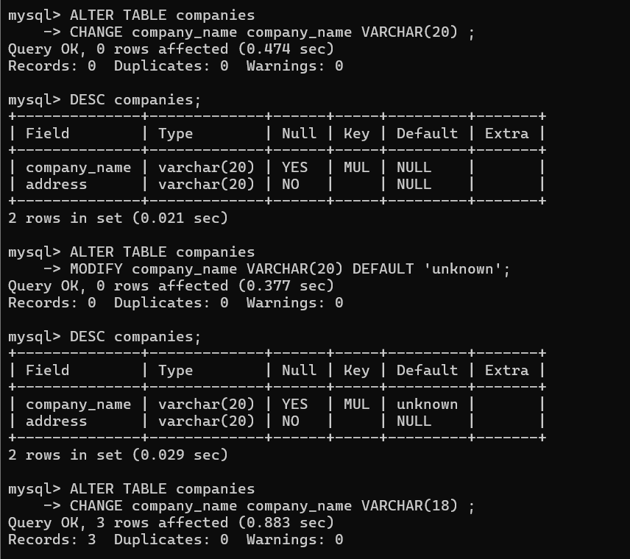

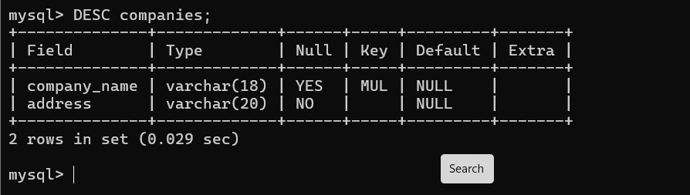

- ALTER TABLE CONSTRAINTS:

- ALTER TABLE houses
- ADD CONSTRAINT positive_pprice CHECK (purchase_price >= 0);
- ALTER TABLE houses DROP CONSTRAINT positive_pprice;

